St Mary’s Chorley PR7 2SR Mount Pleasant, Chorley, Lancashire.
Tour of St Bernadette’s Relics 2022
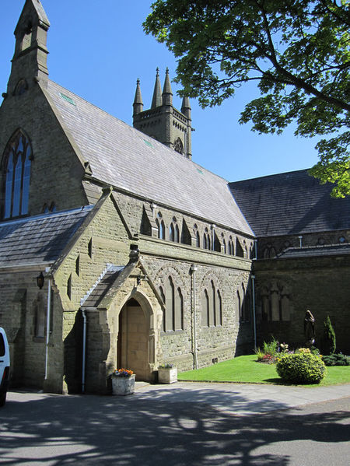
Thursday 15th September 20.30 Arrival and welcome ceremony and Compline: Fr Marsden

Friday 16th September
07.30 Morning Prayer – Fr Marsden
09.00 School Mass Fr Francis Marsden CHURCH SHUT TO PUBLIC
10.00 Church open to public
11.00 Rosary and Litany to St Bernadette – Michael Hall
12.00 Mass – Fr Peter Crowther
14.00 Rosary and Litany to St Bernadette - Deacon Norman Arrowsmith and Knights of St Columba
15.00 Mass - Fr Graeme Dunne VF
17.00 Rosary and Litany to St Bernadette - Members of The Catenians
19.00 Mass and candle procession with ++ His Grace Archbishop M. McMahon OP
21.45 Compline - Deacon Norman Arrowsmith

Saturday 17th September
07.30 Morning Prayer - Fr Marsden
08.00 Mass of Farewell - Fr Marsden
09.00 Departure to Liverpool Anglican Cathedral
Confessions and Anointing available at all public Masses
Wheelchair access available
Loop System available
Toilets available in the church grounds and one of them is an Accessible toilet
Light refreshment available at the nearby parish centre
Parking on West Street Car Park, St Mary’s Car Park, Fleet Street Car Park – all car parks with Council parking fees
Train station and bus station 10 minutes away (on foot)

