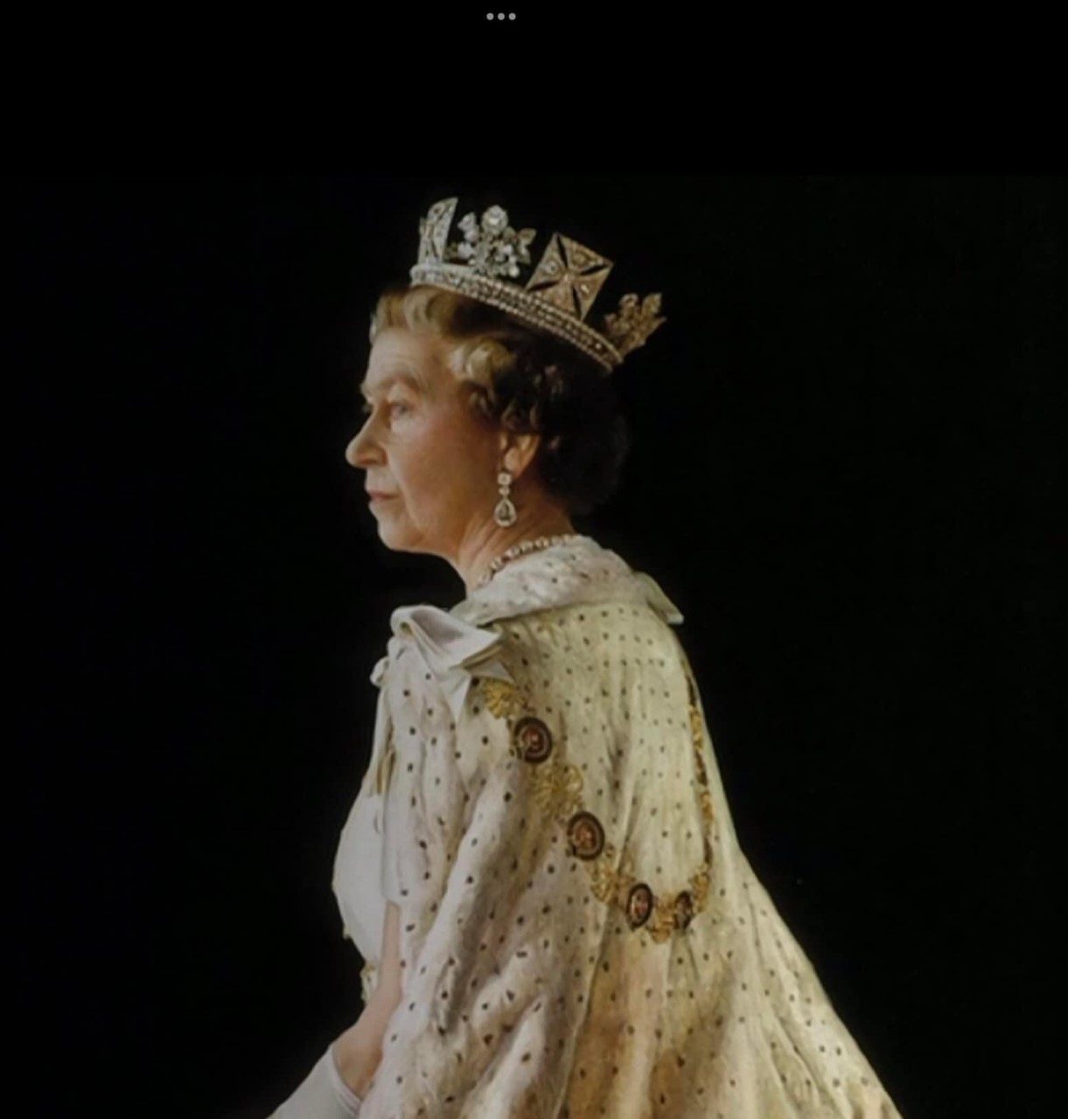

Queen Elizabeth II

Requiescat in Pace

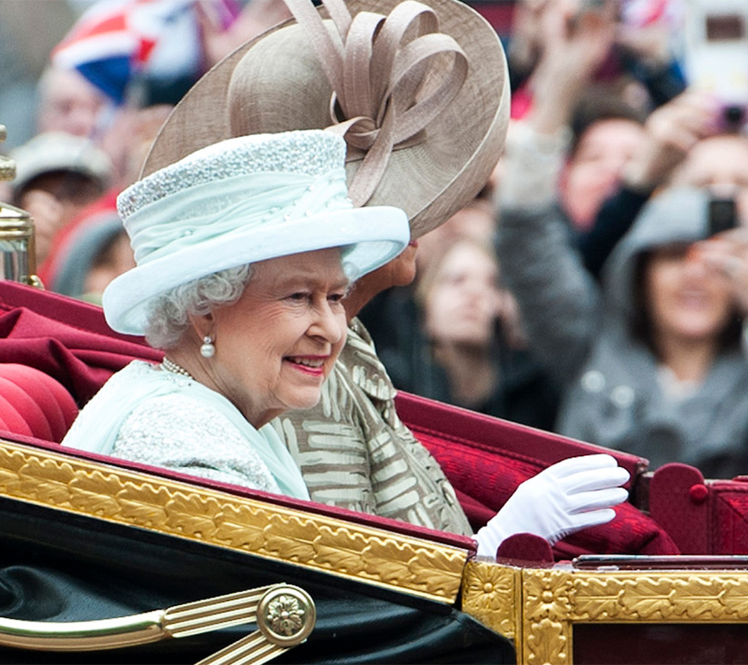

Queen Elizabeth II

Requiescat in Pace

