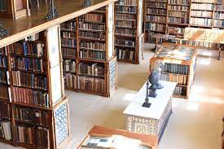
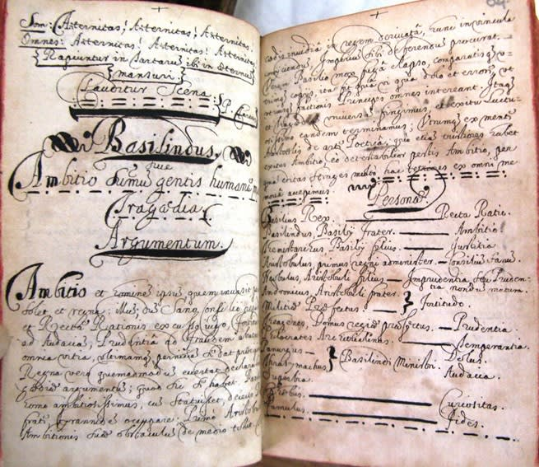

Trip to
Stonyhurst College

Date: Wednesday 23rd August 2023

Time: 11:00 am

Cost: £15 per person

Transport:
‘car share’
suggest leaving OLAS church carpark in
convoy around 10:00 am
or
‘make your own way there’
post code for the college is BB7 9PZ

Journey time and distance by car:
from Parbold: 27 miles and 41 minutes

Any questions at this stage please ring Paul on 07881345451
