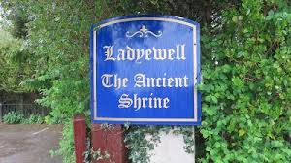
Trip to
Ladyewell

Shrine of Our Lady and Martyrs of Lancashire
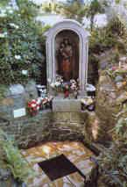
Date: Saturday 30th September 2023

Arrival time: 11:00 am

Cost: Donation

Transport: ‘car share’
meet in OLAS church carpark at 10:15 am
or ‘make your own way there’
post code is PR2 5ST

Journey time and distance by car:
from Parbold: 23 miles and 37 minutes

If interested, please add your name to the list in church, where you can also pick up an itinerary.

For information about the shrine see www.ladyewellshrine.co.uk
