The Virgin Annunciate
by Italian Renaissance artist,
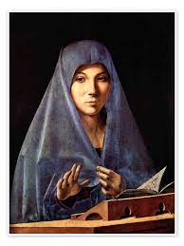
Antonello da Messina

Presentation by Fr Daley,
7:30pm Tuesday 5th December
in the School Hall
All welcome

