Precious Heritage: Masterpieces and hidden gems among the Catholic churches of England and Wales

A talk by author and journalist
Elena Curti based on her recent book:
‘Another Fifty Catholic Churches to see before you die’

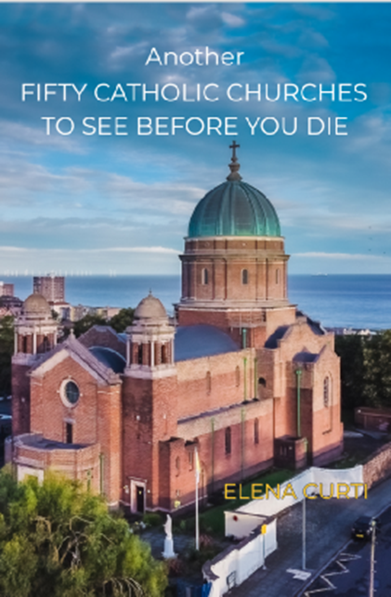

Liverpool Metropolitan Cathedral
11:ooam-1:30pm, Saturday 24th February

Coach + Ticket £22 per person, inc. refreshments

Expressions of interest by 28 January – tickets limited

