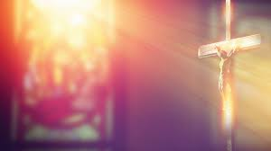
Our Lady and All Saints Church,
Parbold
An Evening of
Recollection for Men
now rearranged for
7:00pm Tuesday 30th April

The evening will start with Mass Our Lady and All Saints Church
at 7:00pm, followed by a talk from Lancaster Lane, Parbold WN8 7HS
Parish Priest Fr Daley, Night Prayer Telephone (01257) 463248
and concluding with supper Email: parbold@hotmail.com
in the Priory www.ourladysparbold.org.uk

